Arduino light dimmer with timer and light sensor

Smart Sun

Design Documentation

VERSION: 1.0

Author: Antonio Gordillo Guerrero
Date: 07/06/14


Contents
Desired Features 3
Previous Ideas 4
Electronic dimmer from www.instructables.com 4
Development 6
Arduino Code 7
Components 15

Desired Features

- Control of the amount of light of a 220VAC lamp.

- Select the time of the dimming in 24h cycles.

- Turn off the light in case of enough light in the ambient.

Previous Ideas

Electronic dimmer from www.instructables.com
http://www.instructables.com/id/Arduino-controlled-light-dimmer-The-circuit/step3/The-software-a-bit-of-theory/- From Guitar amplifier for “small” cabinet with 12'' speaker.

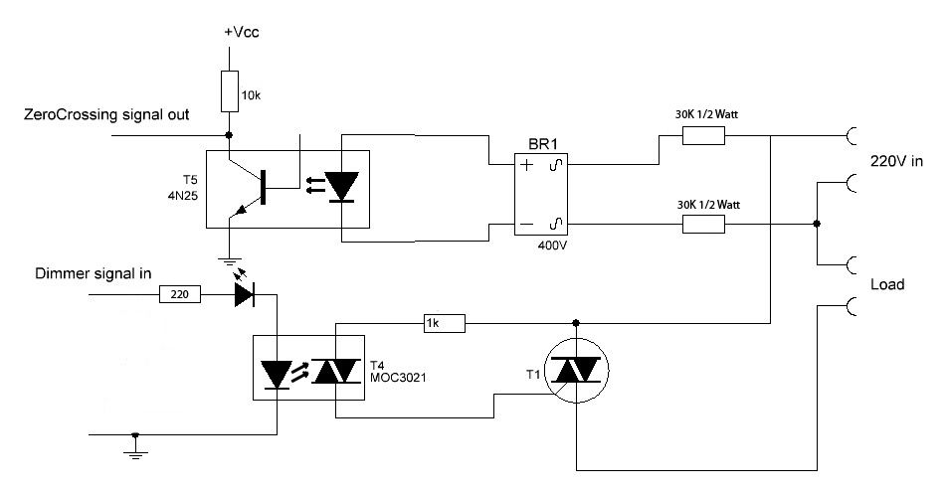

Based on zero-cross detector and pulse controlled TRIAC.

Explanation to set the dimming variables:
There are 2 major net frequencies in the world: 100Hz in Europe and most of Asia and Africa and 120 Hz in the America's (and parts of the Caribean). There are 2 major voltages in the world: 110-120V and 220-240V but they are not important for the mathematics here.

“For ease of use I will take the 50Hz frequency as an example:
50Hz is 50 waves per second. Each sinuswave thus takes 1000ms/50=20ms (miliseconds)
As there are 2 sinuspeaks in a wave that means that after every zero detection there is a 10ms period that we can regulate.
Should we ignite the lamp directly at the beginning of that period, the lamp will receive full power, should we do it at the end of that 10ms period the lamp will receive no ower and should we do it halfway, the lamp will receive half power.
As we are using TRIACs, what the software needs to do is to wait for the zero point at the sinuscurve, take note of that and then wait a specified amount of time within that 10ms period to send a pulse to the TRIAC.
If it sends that pulse at 5ms, the lamp will only burn at half power.”

So we will catch a zero-cross every 10ms.
Note: the Arduino Uno clock cycle is 1/16MHz = 62,5ns.

The code is based on the use of interruptions detected by some pin. On Arduino Uno there are two pins devoted to interruptions. They are located in the physical pins 2 (int. 0) and 3 (int. 1)

Development

I will use an LDR to measure the amount of ambient light.

In my case the LDR has 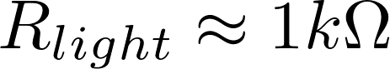, 

I always measure the amount of light in the ambient.

Both the timer and the threshold detector are enabled by an ON/OFF switch each.

The light threshold is selected using a potentiometer.

The sunrise and sunset time is selected with two potentiometers.

Controls:
- General ON/OFF switch.
- Light Sensor ON/OFF switch.
- Off Level threshold potentiometer.
- Timer ON/OFF switch.
- Sunrise time potentiometer.
- Sunset time potentiometer.

Conections to the Ardunio Mini Pro board

- A5 and A4: SCL and SDA for the RTC

- …... Documented in the arduino code

Arduino Code

sdfasdfI will use an LDR to measure the amount of ambient light.

LDR has ,

/*
////////////////////////////////////////////////////////////////
///////////////////////////// SMART SUN ////////////////////////
////////////////////////////////////////////////////////////////

by Antonio Gordillo.
in Caceres. Spain. 2014.
Creative Common License BY-NC-SH
Code Version: 1.0

Based on:
- AC Light Control Updated by Robert Twomey
Zero-crossing detection to dim the light
Adapted from sketch by Ryan McLaughlin
http://www.arduino.cc/cgi-bin/yabb2/YaBB.pl?num=1230333861/30

- Tiny RTC I2C Module to control the real time

V1.0: Includes:
- Adaptation to the Arduino Mini Pro board
- Turn the light off when a given threshold is readed in a analog input pin
- Switch for on/off the light sensor (LDR) functionality
- Switch for on/off the timer functionality
- Read the sunrise and sunset time from potentiometers
- Implement the dim control using the actual hour and using the lectures for sunrise and sunset
- Switch for set the clock time to 12:00h after pressing 3 seconds
- 100 dim levels (freqStep=100) but only using levels from 20 till 80 (to ensure a real effect on the light of an incandescent bulb)

*/

//////////////////////////////////////////////////////////////
// Libraries
//////////////////////////////////////////////////////////////
#include <TimerOne.h> // Avaiable from http://www.arduino.cc/playground/Code/Timer1
#include <Wire.h> // Incluye la librería Wire
#include "RTClib.h" // Incluye la librería RTClib

#define SERIAL_ON // used to send dat through serial or not

////////////////////////////////////////////////////////////////////////////////////////////////////////////////
// Pin definitions
////////////////////////////////////////////////////////////////////////////////////////////////////////////////

// A5 and A4 are for the RTC (SDL and SCA, respectively)
// Pin 2 is used to detect the interruption of the raising edge of the 220VAC signal

int AC_pin = 4; // Output to Opto Triac
int LDRinputPin = A0 ; // Input from the LDR
int ThresholdPin = A3 ; // Input from the LDR

int sunriseTimePin = A1 ; // Input from the set-sunrise-time potentiometer
int sunsetTimePin = A2 ; // Input from the set-sunset-time potentiometer

int LDRswitchPin = 6 ; // Pin for the digital input to enable the light sensor
int timerswitchPin = 7; // Pin for the digital input to enable the timer to control the light level
int setClockTimePin = 8; // Pin for the digital input to set the clock time to 12:00h.
int setClockLedPin = 13; // Pin for the digital output to blink the led after setting time.

////////////////////////////////////////////////////////////////////////////////////////////////////////////////
// Variable definitions
////////////////////////////////////////////////////////////////////////////////////////////////////////////////

volatile int i=0; // Variable to use as a counter
volatile boolean zero_cross=0; // Boolean to store a "switch" to tell us if we have crossed zero

int dim = 0; // Dimming level (0-128) 0 = on, 128 = 0ff

int freqStep = 100; // This is the delay-per-brightness step in microseconds.
// It is calculated based on the frequency of the voltage supply (50Hz)
// and the number of brightness steps.
//
// The chopper circuit chops the AC wave twice per cycle, once on the positive half and once
// at the negative half. This meeans chopping happens at 120Hz for a 60Hz supply or 100Hz for a 50Hz supply.

// To calculate freqStep divide the length of one full half-wave of the power
// cycle (in microseconds) by the number of brightness steps.
//
// (1000000 uS / 100 Hz) / 100 brightness steps = 100 uS / brightness step
//
// 1000000 us / 100 Hz = 10000 uS, length of one half-wave.

//LDR sensor variables
int LDRswitchValue;
int LDRinputValue;
int threshold;

//timer variables
RTC_DS1307 RTC; // RTC object definition
int timerswitchValue;
int sunriseTime;
int sunsetTime;
int seconds;
int minutes;
int hours;
int minutes_from_midnight;

// millis variables
long millis_waiting_time = 2000; // interval to change the dimming level
unsigned long currentMillis;
unsigned long previousMillis;

// set clock variables
int buttonState;
int lastPushTime = 0; // the last time the button was pushed
int pushDelay = 3000; // time needed pushing the button to set the time
int lastButtonState = LOW; // the previous reading from the input pin
int Pushed=0; // active when the button is pushed
int j;
/////////////// Functions ////////////////////////

// set flag when interrupt is detected (rising edge) and turn off the triac
void zero_cross_detect() {
zero_cross = true; // set the boolean to true to tell our dimming function that a zero cross has occured
i=0;
digitalWrite(AC_pin, LOW); // turn off TRIAC (and AC)
}

// Turn on the TRIAC at the appropriate time indicated by dim
void dim_check() {
if(zero_cross == true) {
if(i>=dim) {
digitalWrite(AC_pin, HIGH); // turn on light
i=0; // reset time step counter
zero_cross = false; //reset zero cross detection
}
else {
i++; // increment time step counter
}
}
}

// Light level control using the date. Test version with a complete day of only 4 minutes.
void timer_light_control_4minutes() {
////////////////////////////////
// Daytime Light level control
////////////////////////////////
///// Playing with a 4 minutes day
// starting the sunrise at minute 0
if(((minutes%4)==0)){
#ifdef SERIAL_ON
Serial.print(" Current Mode: SUNRISE ");
Serial.println();
#endif
dim=(79-seconds);// using only levels [20-80]
}
//keeping the maximum light in the minute 1
if(((minutes%4)==1)){
#ifdef SERIAL_ON
Serial.print(" Current Mode: DAY ");
Serial.println();
#endif
dim=0;
}
// starting the sunset at minute 2
if(((minutes%4)==2)){
#ifdef SERIAL_ON
Serial.print(" Current Mode: SUNSET ");
Serial.println();
#endif
dim=20+seconds;// using only levels [20-80]
}
// keeping the minimum light during minute 3
if(((minutes%4)==3)){
#ifdef SERIAL_ON
Serial.print(" Current Mode: NIGHT ");
Serial.println();
#endif
dim=99;
}
}

// Light level control using the actual time registered in the RTC.
void timer_light_control() {

// starting the sunrise when minutes_from_midnight>=sunriseTime
if((minutes_from_midnight>=sunriseTime)&&(minutes_from_midnight<sunriseTime+60)){
#ifdef SERIAL_ON
Serial.print(" Current Mode: SUNRISE ");
Serial.println();
#endif
dim=79-(minutes_from_midnight-sunriseTime); // using only levels [20-80]
}
// keeping maximum light from 60 minutes after sunrise till the sunset time
if((minutes_from_midnight>=sunriseTime+60)&&(minutes_from_midnight<sunsetTime)){
#ifdef SERIAL_ON
Serial.print(" Current Mode: DAY ");
Serial.println();
#endif
dim=0;
}
// starting the sunset when minutes_from_midnight>=sunsetTime
if((minutes_from_midnight>=sunsetTime)&&(minutes_from_midnight<sunsetTime+60)){
#ifdef SERIAL_ON
Serial.print(" Current Mode: SUNSET ");
Serial.println();
#endif
dim=20+minutes_from_midnight-sunsetTime;// using only levels [20-80]
}
// keeping minimum light from 60 minutes after sunset till the sunrise time
if((minutes_from_midnight>=sunsetTime+60)||(minutes_from_midnight<sunriseTime)){
#ifdef SERIAL_ON
Serial.print(" Current Mode: NIGHT ");
Serial.println();
#endif
dim=99;
}
}

// Print information to Serial port
void print_to_serial() {

Serial.println();
// Serial.print("//////////// SMART SUN ///// by A.Gordillo 2014");
// Serial.println();
if(LDRswitchValue==HIGH){
Serial.print("LDR control enabled");
Serial.println();

//send data to serial port
Serial.print(" LDR input value: ");
Serial.print(LDRinputValue);
Serial.println();
Serial.print(" Threshold value: ");
Serial.print(threshold);
Serial.println();
}
else
{
Serial.print("LDR control disabled");
Serial.println();
}

if(timerswitchValue==HIGH){
Serial.print("Timer control enabled");
Serial.println();
Serial.print(" Time: ");
Serial.print(hours, DEC);
Serial.print(':');
Serial.print(minutes, DEC);
Serial.print(':');
Serial.print(seconds, DEC);
Serial.println();
/* Serial.print(" Minutes from midnight: ");
Serial.print(minutes_from_midnight);
Serial.println(); */
Serial.print(" Sunrise time: ");
Serial.print(sunriseTime/60);
Serial.print(':');
Serial.print(sunriseTime%60);
Serial.print("h ; Sunset time: ");
Serial.print(sunsetTime/60);
Serial.print(':');
Serial.print(sunsetTime%60);
Serial.print("h");
Serial.println();

}
else
{
Serial.print("Timer control disabled");
Serial.println();
}

}

///////////////////// SETUP /////////////////////////////////

void setup() {

#ifdef SERIAL_ON
Serial.begin(9600); // Set data speed in the serial port
#endif

Wire.begin(); // Set the wire communication
RTC.begin(); // Set the RTC functionality

// Adjusting time for testing
// RTC.adjust(DateTime(2014, 1, 1, 6, 00, 00));

RTC.adjust(DateTime(__DATE__, __TIME__)); // Set the date according to the connected PC's time. Uncomment to set the clock after battery replacement.

pinMode(AC_pin, OUTPUT); // Set the Triac pin as output
attachInterrupt(0, zero_cross_detect, RISING); // Attach an Interupt to Pin 2 (interupt 0) for Zero Cross Detection
Timer1.initialize(freqStep); // Initialize TimerOne library for the freq we need
Timer1.attachInterrupt(dim_check, freqStep);

//Digital I/O pin modes
pinMode(AC_pin, OUTPUT); // Pin for turning ON/OFF the Triac.
pinMode(LDRswitchPin, INPUT); // Pin to enable the light sensor
pinMode(timerswitchPin, INPUT); // Pin to enable the timer to control the light level
pinMode(setClockTimePin, INPUT); // Pin to set the clock time to 12:00h.
pinMode(setClockLedPin, OUTPUT); // Pin to blink the led after setting time.
digitalWrite(setClockLedPin, LOW);

}

///////////////////// LOOP /////////////////////////////////

void loop() {

currentMillis = millis(); // Get current mseconds from millis

DateTime now = RTC.now(); // Get current date from RTC

// read the value from the LDR sensor ON/OFF switch:
LDRswitchValue = digitalRead(LDRswitchPin);
// read the value from the timer ON/OFF switch
timerswitchValue = digitalRead(timerswitchPin);
// read the value from the sensor:
LDRinputValue = analogRead(LDRinputPin);
// read the value from the threshold potentiometer
threshold = analogRead(ThresholdPin);

// read the value from the sunrise time potentiometer
sunriseTime = analogRead(sunriseTimePin);
sunriseTime = map(sunriseTime, 0, 1023, 0, 195); // read the value from the sunset time potentiometer
//converting in minutes from 00:00h taking into account that the limits are 4:53h and 8:07h
sunriseTime += 293; // 293 minutes from midnight till 4:53h

sunsetTime = analogRead(sunsetTimePin);
sunsetTime = map(sunsetTime, 0, 1023, 0, 195); // read the value from the sunset time potentiometer
//converting in minutes from 00:00h taking into account that the limits are 4:53h and 8:07h
sunsetTime += 1133; // 293 minutes from midnight till 18:53h
// auxiliar timer variables
minutes_from_midnight=minutes+hours*60;
seconds=now.second();
minutes=now.minute();
hours=now.hour();

////////////////////////////////////////////////////////////////////
//check the set clock button
pinMode(setClockTimePin, INPUT); // Pin to set the clock time to 12:00h.
buttonState=digitalRead(setClockTimePin); // Pin to set the clock time to 12:00h.

if ((buttonState == HIGH)&&(!Pushed)) {
lastPushTime = currentMillis;
Pushed=1;
}

if ((buttonState == HIGH)&&(Pushed)) {
if ((currentMillis - lastPushTime) > pushDelay) {
RTC.adjust(DateTime(2014, 1, 1, 12, 00, 00));
for(j=0;j<8;j++){ //blink the LED eight times
digitalWrite(setClockLedPin, HIGH);
delay(200);
digitalWrite(setClockLedPin, LOW);
delay(200);
}
}
}
if (buttonState == LOW) {
Pushed=0;
}
//////////////////////////////////////////////////////////7

// Temporized stuff using millis()
if(currentMillis - previousMillis > millis_waiting_time){
// guardar el ultimo instante en el que se movio el servo
previousMillis = currentMillis;

// Printing to serial port
#ifdef SERIAL_ON
print_to_serial();
#endif

////////////////////////////////
// LDR control
////////////////////////////////
// when the sensor functionality is ON
if(LDRswitchValue==HIGH){

// Turn the light off when thresold is reached
if(LDRinputValue>=threshold){
dim=99; // turn off light
}
else {// else if threshold is not reached, use the timer control or turn it on

// If timer is enabled
if(timerswitchValue==HIGH){
timer_light_control();
// timer_light_control_4minutes();
} // end if the timer switch is ON
else{ // end if the timer switch is ON turn ON the light
dim=0;
}

} // end else if not threshold is reached

} // end when the LDR sensor functionality is ON
else
{ // else when the LDR sensor functionality is OFF

// If timer is enabled
if(timerswitchValue==HIGH){
timer_light_control();
// timer_light_control_4minutes();
} // end if the timer switch is ON
else
{ // end if the timer switch is OFF and the LDR sensor is OFF turn ON the light
dim=0;
}

} // end when the sensor functionality is OFF

} // end of the millis() condition

} /////////////////////// END LOOP ///////////////////////

Components

TRIAC

I use model BTA12-600: http://www.haopin.com/PDF/BTA12-600B.pdf
Prize approx. 1€

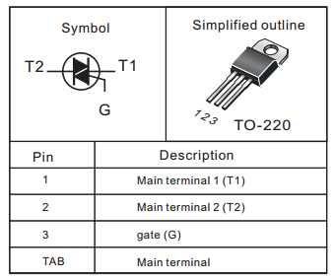

Optocoupler: LED+phototransistor
I use H11AA1
Prize approx. 1€

Optocoupler: LED+TRIAC
I use MOC3020
Prize approx. 0,5€

Arduino Mini Pro 5V

5V Power supply

RTC I2C module

